**DMC**

**DATE: 31 October 2018**

**TIME: 14:40 - 15:30**

**ATTENDEES** Tom Gibbs, Elliot Chester | George Flude

Henry unable to attend impromptu meeting at such short notice due to commute time.

***COMMON ROOM, PROGRAMMING LABS***

**Meeting Aim:**

* To clarify art assets artist will provide for team
* Negotiate completion date for the assets

**Meeting Minutes:**

Tom was contacted by George Flude, who had previously agreed to produce the teams 2D mascot assets. George advised that he has now produced design iterations of the cat mascot poses, outfits and mouth shapes for animations. Meeting was arranged with George to review his work and discuss how to proceed. Henry unavailable to attend at such short notice – agreed that meeting should take place asap.

George presented iterations to the team allowing for deep discussion of the style and content the team desire.

From the designs the team selected the elements most appropriate for the application and agreed on the final design of mascot poses, idle animations and mouth positions.

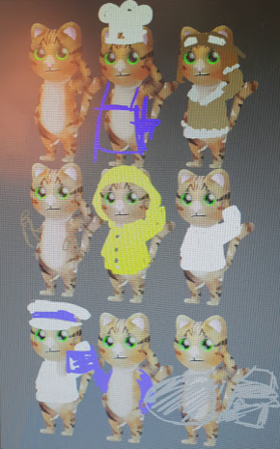

Mascot appearance corresponding to AR events 1 – 9. Quick drafts done by George in meeting. Pictures do not represent order of events.

Team agreed on designs of mascots to correspond to AR events 1-9:

1: Whopsie the cat - waving pose, cat without accessories

2: Take off - salute pose, goggles and aviator jacket

3: Gondola – cat holding onto airship steering wheel

4: Crew – salute pose, uniform without hat and rank insignia

5: Stowaway – arms at side pose, chef uniform

6: Inclement conditions – salute pose, rain hat, rain coat

7: Major – salute pose, uniform with hat, insignia on collar of uniform and hat

8: NY landing – wave pose, American flag accessory

9: Homecoming – wave pose, British flag accessory

George advised he expects to complete assets by 20/1/2019.

George will work each model to completion before begging work on the next.

Each one will be received when complete with the last being sent by 20/1/2019.

Next team meeting arranged for Friday 2 November @ 13:30.

**Tasks for the current week:**

* **HC - total time: 5h 15mm**
* **HC: Set up battery saver functionality (1h)**
* **HC: ‘Take off’ AR Event (3h 45m)**
  + **Find free use model of the R34 hangar – animate this to open, revealing the airship before take-off (1h 30m)**
  + **Animate take off (1h)**
  + **Import Peter’s model (10m)**
  + **Particle effects (45m)**
  + **Designing AR Event layout suitable for mobile device (30m)**
* **EC – total time: 4h 45m**
* **EC: Code review with Tom Gibbs to determine approach for adding functionality to application mascot (15m)**
* **EC: ‘Crew’ AR Event (4h)**
  + **AR Perspective effect (1h 30m)**
  + **Designing AR Event layout suitable for mobile device (30h)**
  + **Prepare mascot animations and mascot UI textbox within AR event to allow brief description of event (2h)**
* **TG – total time: 4h 50m**
* **TG: Code review with Elliot Chester to determine approach for adding functionality to application mascot (15m)**
* **TG: Update functionality of application mascot to show more relevant sprites/animations/text depending on user interaction and application progress (1h 30m)**
* **TG: 3D model control within information screens (1h 30m)**
* **TG: Add Peter Paterson WhatsApp correspondence to group repository, Add Client email correspondence to group repository (5m)**
* **Begin review of research gathered so far to identify areas that lack sufficient detail and must be explored in the coming sprints (1h)**
* **All: Sprint review meeting, Friday 2 November 2018 (30m).**

**Detailed task breakdown, task descriptions and time estimates added to JIRA sprint.**